ENGLISH STUDY WORKSHEET
(III Medio)

“Comprehension activity”

UNIDAD 1: My skills and achievements contribute to the society itself

OBJETIVO DE LA CLASE: Comprender texto oral a través de un video relacionado a entrevista de trabajo.
OA 1 / OA 4

Name:_________________________________________Date:_________________

Mark:_________________

Name of the Video: Job interview… good example
Youtube link: https://www.youtube.com/watch?v=SieNfciN274

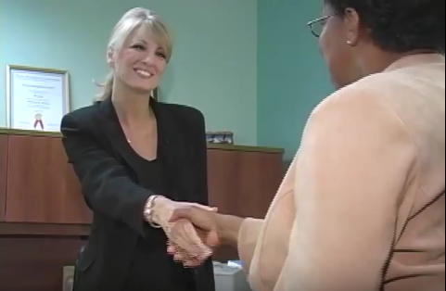

I. Watch and listen to the job interview that Tamara had with Stephanie and answer the next questions.

a) What position is Tamara interviewing for?

____________________________________________________________________

b) Where did Tamara see this job position posted?

____________________________________________________________________

c) What is the experience that Tamara has in Human Resources?

____________________________________________________________________

d) What qualities is Tamara looking for when she is interviewing someone?

____________________________________________________________________

e) How many chances will Tamara give to workers that are late in a period of six months?

____________________________________________________________________

f) What does Tamara’s co-workers say about her qualities?

____________________________________________________________________

g) What does Tamara need to improve a little better?

____________________________________________________________________

h) What does Tamara think it takes to be a good employee?

____________________________________________________________________

i) Why does Stephanie need a new Human Resources Assistant?

____________________________________________________________________

II. Answer the next questions related to the content of the video and your personal analysis from it.

a) Is Tamara ready for the job? Why?

____________________________________________________________________

____________________________________________________________________

b) Is Stephanie interested on hiring Tamara? Why?

____________________________________________________________________

____________________________________________________________________

c) Would you hire Tamara? Why?

____________________________________________________________________

____________________________________________________________________

d) How Stephanie reacts to the answers that Tamara gave in the interview? Why?

____________________________________________________________________

____________________________________________________________________

e) What do you think about the interview? Was it good? Was it bad? Why?

____________________________________________________________________

____________________________________________________________________

III. Write formal expressions that Stephanie and Tamara used in their respective Job interview.

Stephanie:

____________________________________________________________________

____________________________________________________________________

Tamara:

____________________________________________________________________

____________________________________________________________________

